Population Health
Capstone Community Preventive Health Improvement: GCP Assignment #GEA2

COVID 19 Reminders- Practice Social distancing, use a mask in public, & good handwashing.
According to the University of South Florida FKL Core Curriculum for Students, Capstone courses provide students with a culminating educational experience for the major. Capstone courses within the major discipline typically bring together knowledge from the discipline into a culminating learning experience for deeper understanding of the discipline. These courses, by definition, must lead to a summative product such as a project, a paper, a proposal, or a performance. This assignment also meets the Global Citizens Project required assessment.
For this problem-based Capstone/GCP assignment, the student will prepare an evidence-based (or “promising practice”) community preventive health improvement plan to meet the assessed health needs of a selected population and community.
The scenario: With your background as a nurse and the information you have gathered throughout this course so far, you have identified a health behavior to address among the population to potentially improve the health of the community.
- To address the identified unhealthy behavior in the community, using the content learned in this course and building on content for the major, the student will articulate the identified assessed health need from the investigation and the risks associated with the identified unhealthy behavior for a selected population.
- Then the student will develop and propose a plan based on an evidence-based or promising practice tailored to your community. The intervention must be directed at the level of the community directed towards the target population with a focus on health promotion or disease prevention. The intervention must not occur within the acute care setting.
Below you will find the required elements of this assignment. All submissions are expected to be well written, with proper grammar and spelling. Include a cover page, introduction, body, and summary/conclusion. Remember, this is a scholarly paper and must include citations of scholarly and evidence-based literature. A minimum of six (6) scholarly references are required for this paper. We strongly recommend you begin by searching the Cumulative Index of Nursing and Allied Health Literature (CINAHL) through Shimberg library.
The length of the paper should be no more than 7 pages excluding the title page and reference page. If your paper is any longer, please contact your instructor to help you to narrow down the scope. Papers longer than 7 pages will be returned. A template is provided in the assignment on canvas.
Requirements:
- Introduction (approximately 1 paragraph-2 paragraphs)-Reminder the title of the paper goes at the top of the page in bold per APA 7th ed. The word INTRODUCTION would not be considered the level heading.
- Background (approximately 1-2 pages)
  - Selected Population. Identify the HEALTH BEHAVIOR selected and the population at risk. Discuss the findings from your assessment of the population at risk and demonstrate the need for an intervention. Use the data you evaluated, discuss socioeconomic considerations, and support the selection with evidence from the literature including data sets. Why is it important to address this problem? Why this population? Discuss demographic, cultural, and socioeconomic factors related to your population.
  - Community Location. Discuss the findings from your assessment supporting the need for an intervention in the selected community. Will the impact of your intervention affect a broader population? Will the community support the intervention? Use the data you evaluated in your community assessment. This section may be 1 paragraph.
- Promising Practice for a Community Intervention.
  - Intervention Selected -Identify the promising practice or community intervention*** DO NOT MAKE IT UP ***you found in the literature. Discuss the elements of the promising practice plan or intervention (what will be done in the community? Education, teaching plan, group activity?) and why this may be appropriate for your intervention and population. How or what will you need to adapt your plan to the needs of your population and community (Are there similarities in the demographics for example). This will be approximately 2-3 paragraphs.
  - Plan Effectiveness/ Outcomes. Include a synthesis of the evidence of success or effectiveness pending more rigorous evaluation (i.e. promising practice) of the chosen intervention (minimum of three (3) supporting evidence articles which are U.S. based within the last 10 years access the librarian if necessary). If the evidence you found does not exactly fit your health need identified but principles of the intervention are appropriate and transferrable provide the evidence to support the efficacy. (May not have strong evidence yet for educating the community about COVID but evidence for education and community strategies are readily available for other infectious disease community outreach and prevention programs. Analyze and discuss the effectiveness of the selected plan/intervention based on the data and outcomes supporting your plan/intervention. Discuss why the program you have identified will be effective to use as a model in your own community with your at risk population including the benefits. This should be one paragraph NOT a paragraph per supporting article.
  - Level of Prevention. Discuss the intervention’s focus on health (e.g. Incidence? Prevalence? Mortality? Morbidity?) and which level of prevention (p. 31) the program/intervention specifically addresses (see Chapter 3) be sure to use citations to support your discussion. Remember three sentences for a paragraph.
  - Healthy People 2020-30 Goals. Make the connection of the specific health behavior and the intervention selected to address the appropriate HP 2020-30 goal. Which national goals will you address? Use citations as necessary from HP 2020-30. Transition to how the following plan will impact the community or population based on the evidence you found in the literature.
- Implementation Describe how the intervention will be applied in the community. The community intervention will be provided for the public as well as the subset of the population. Discuss the location, materials and resources needed to implement the project. (3 sentences for a paragraph)
  - Objectives. In this section, list TWO measurable objectives for your project using SMART format (refer to the guidelines below for further information). This will be the evaluation mechanism. May use one process measurement, proximal to the intervention process, and one outcome measurement if appropriate (SEE TEMPLATE FOR EXAMPLES). Use data sources you can access to evaluate the objectives. Remember to consider the data collected describing the health behaviors in your community currently, to use as a benchmark to where you hope to be based on the interventions you choose (Measurement).
  - Evaluation Plan. Describe and discuss the plan or means to measure your objectives. Use data sources you can access to evaluate outcomes with measures. Describe how you will measure the effectiveness. Use the SMART objective as a benchmark. Can you find the data easily? Remember to relate back to the objectives for the project. Consider how the intervention was measured in your model program as a guide? (SEE TEMPLATE FOR EXAMPLES)
- Limitations and Recommendations. In this section, review and describe the potential limitations you can identify based on your experiences in the community and any recommendations from the model intervention. What is the likelihood of sustaining the intervention? Describe recommendations for the future noting gaps and additional resources or programs to consider. Are the collaborators invested, is the community poised for success? Have you found resources available but not well advertised? Discuss lessons learned and your role in the assessment, planning, intervention and evaluation of the project. What could be done differently?
- Conclusion. The summary must be specific to the content of your paper and summarizes the conclusions you have made about the need and plan for the intervention. New content should not be introduced in the summary and therefore generally citations are not needed in the summary.

Resources and hints:
Use the paper Template as a guide for organization and content needed in the paper
Please remember to review Module 4 carefully. While you may choose a website for the intervention details/promising practice make sure to go to the literature for support of the project. Most projects have scholarly publications that are associated with the recommendations.
A minimum of six (6) references are required for this paper. All references should be dated. (E.g. CDC, CMS.gov, Robert Wood Johnson Foundation, Joint Commission HHS.gov, etc.). Three of the references must be recent, from evidence-based and/or peer-reviewed sources, and used to support your ideas and responses. Your text can serve as one of these three peer-reviewed sources. The other three references must be the related to the evidenced based intervention.
SMART FORMAT –see template for examples
To write SMART objectives, address each of the key components.
S=specific
M=measurable
A=achievable
R=realistic
T=timely

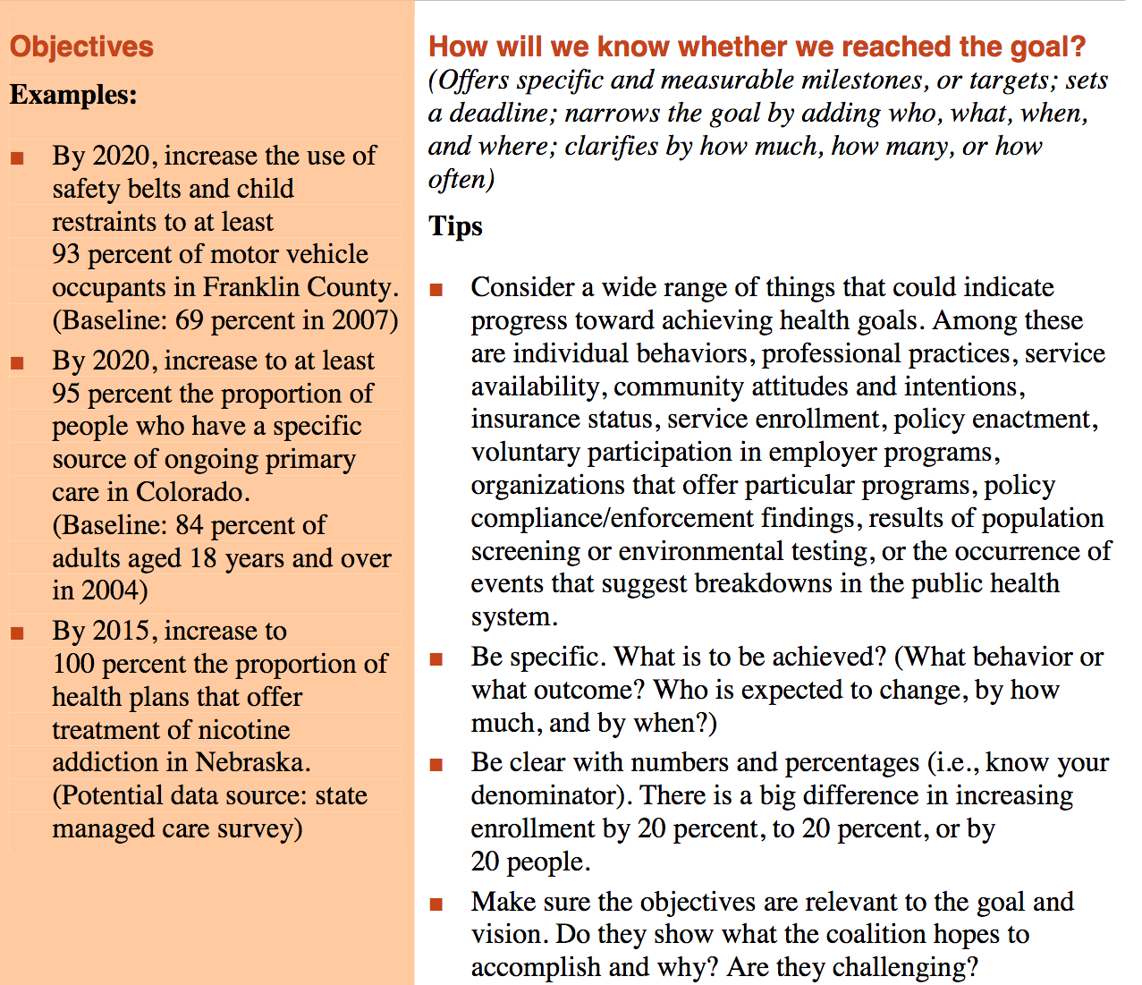

U.S. Department of Health and Human Services. (2018). Defining terms: Vision, goal, and objective strategy. Healthy People 2020. Retrieved from https://www.healthypeople.gov/sites/default/files/DefiningTerms.pdf
Remember to think about how to measure your outcome based on what you objective statement.

